HW2 – Testing Data-Screenshot

(for details, please see “Multiple_year_stock_data BHart”)

Tab 2016

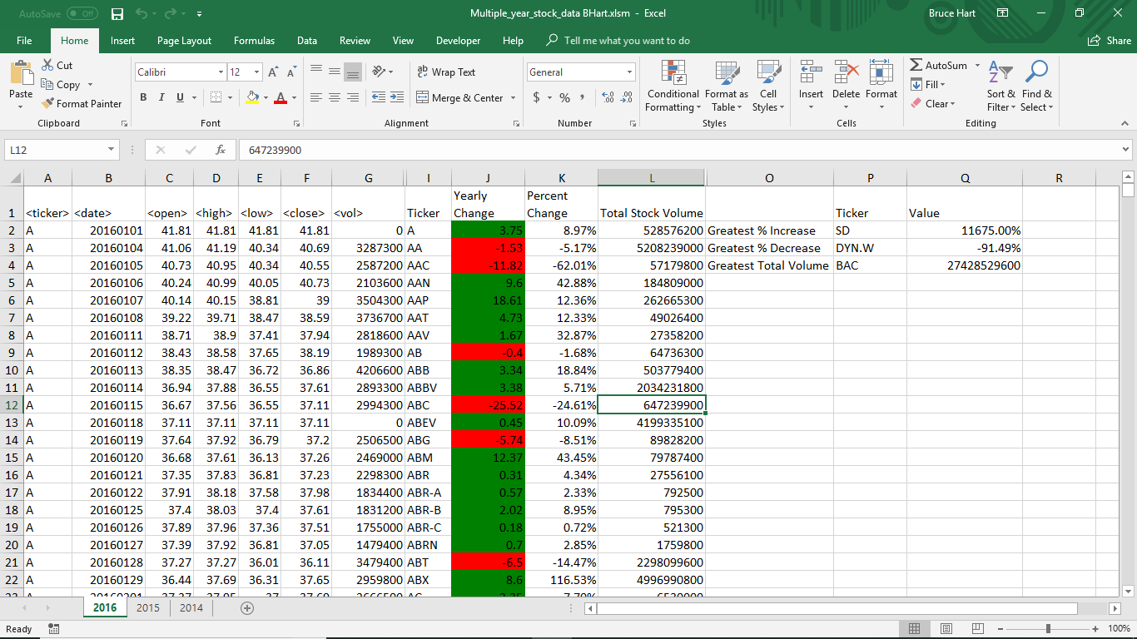

Tab 2015

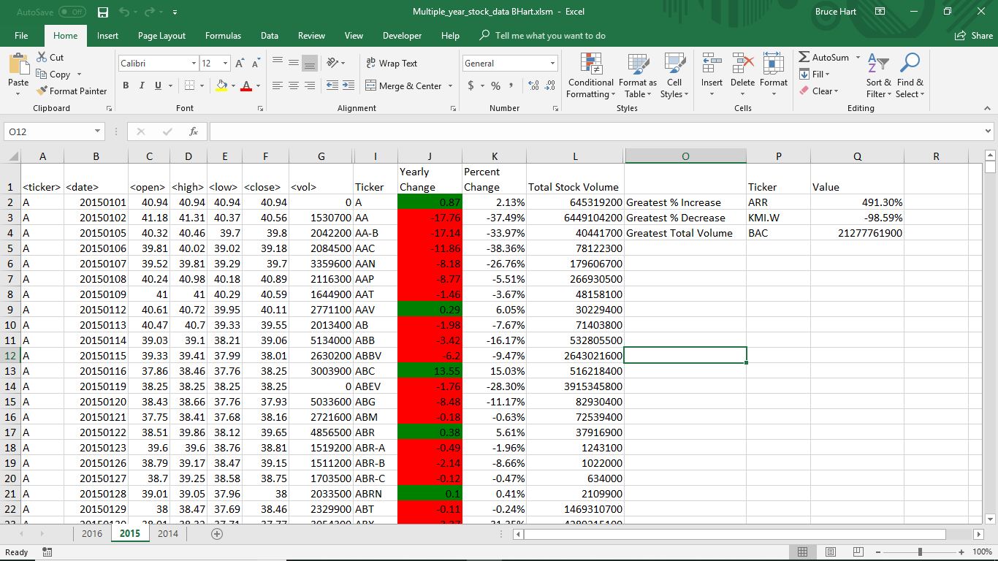

Tab 2014

